Project Design Phase-II
Data Flow Diagram & User Stories
Date | 01 October 2026
Team ID | SWTID-2026-4457
Project Name | Script-Controlled ACL – Restrict Record Access Based on Field Value
Maximum Marks | 4 Marks

Data Flow Diagrams:
A Data Flow Diagram (DFD) is a traditional visual representation of the information flows within a system. A neat and clear DFD can depict the right amount of the system requirement graphically. It shows how data enters and leaves the system, what changes the information, and where data is stored. In this project, the DFD shows how a user's request to view, create, edit or delete a record in the u_institution_details table is checked by a Script-Controlled ACL. The script checks the user's role and the record's field value (Branch = EEE), and access is granted only when the ACL script evaluates to true.
Example: (Simplified)
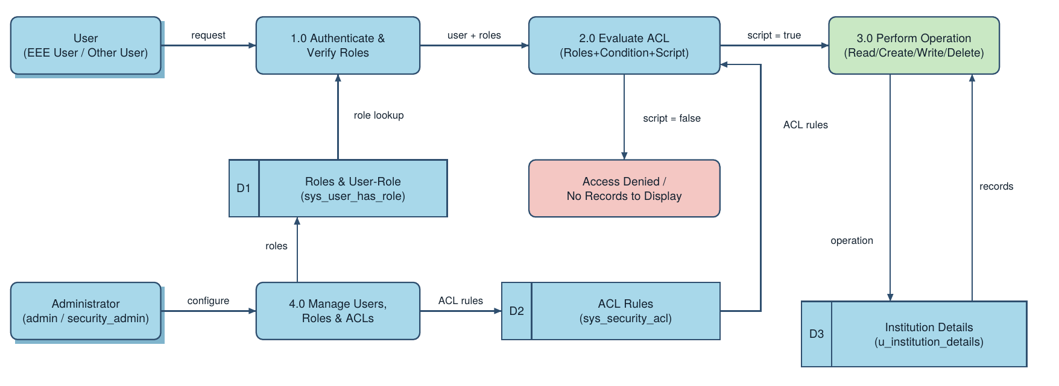
Flow Description
- Administrator logs in to the ServiceNow instance, creates the EEE User and the custom roles bb1, bb2, bb3 and bb4, and assigns all roles to the EEE User.
- Administrator creates the custom table Institution Details (u_institution_details) with fields Student Roll Number, Student Name, Faculty Name, Branch (ECE, EEE, CSE), Email, Phone Number and Description, and adds sample records.
- Administrator elevates to security_admin and creates the Read, Create, Write and Delete ACLs on u_institution_details (bb1, bb2, bb3 and bb4 respectively).
- The Read ACL is set to Advanced with data condition Branch is EEE and a script that returns true for admin or bb1 and false for everyone else.
- A user opens the Institution Details list (u_institution_details.list). ServiceNow reads the user's roles and evaluates the ACL rules stored for the table.
- If the ACL script evaluates to true, the matching records (EEE branch only) are returned from the table; if it evaluates to false, the user sees "No records to display". Admin can view all records.
- Create, edit and delete operations are allowed only when the user also holds bb2, bb3 and bb4 respectively.
ACL Script Used (Read ACL):
(function () {
// Allow admin users full access
if (gs.hasRole('admin')) { return true; }
// Allow only EEE branch users (bb1) to see EEE records
if (gs.hasRole('bb1')) { return true; }
// Deny access for all others
return false;
})();
User Stories
Use the below template to list all the user stories for the product.
User Type | Functional Requirement (Epic) | User Story Number | User Story / Task | Acceptance criteria | Priority | Release
Administrator | User & Role Management | USN-1 | As an administrator, I can create a test user (EEE User) with user ID, name and email. | EEE User is created and saved in the Users list | High | Sprint-1
 |  | USN-2 | As an administrator, I can create the custom roles bb1, bb2, bb3 and bb4 and assign them to the EEE User. | All four roles are visible on the EEE User record | High | Sprint-1
 | Table Creation | USN-3 | As an administrator, I can create the custom table Institution Details (u_institution_details) with all required fields. | Table is saved with Roll Number, Student, Faculty, Branch, Email, Phone and Description fields | High | Sprint-1
 |  | USN-4 | As an administrator, I can add sample student records with different branch values (ECE, EEE, CSE). | Records are listed with ECE, EEE and CSE branches | Medium | Sprint-1
 | Read ACL | USN-5 | As an administrator, I can create a script-controlled Read ACL with data condition Branch is EEE and role bb1. | ACL is saved as Advanced with the script and is active | High | Sprint-1
EEE User (bb1) | Read ACL | USN-6 | As an EEE user with role bb1, I can view only the EEE branch records. | List shows only records where Branch = EEE | High | Sprint-1
User without role | Read ACL | USN-7 | As a user without the required role, I cannot view any records of the table. | List shows "No records to display" | High | Sprint-1
Administrator | Read ACL | USN-8 | As an administrator, I can view all records regardless of branch. | All ECE, EEE and CSE records are visible | High | Sprint-1
EEE User (bb1 + bb2) | Create ACL | USN-9 | As a user with roles bb1 and bb2, I can create new records using the New button. | New button appears and a record can be created | Medium | Sprint-2
EEE User (bb1 + bb2 + bb3) | Write ACL | USN-10 | As a user with roles bb1, bb2 and bb3, I can edit the EEE branch records. | Fields (e.g. Description) can be edited and saved | Medium | Sprint-2
EEE User (bb1 + bb2 + bb3 + bb4) | Delete ACL | USN-11 | As a user with roles bb1 to bb4, I can delete the EEE branch records. | Selected record is deleted after confirmation | Medium | Sprint-2
Administrator | Verification | USN-12 | As an administrator, I can impersonate the EEE User and Admin to verify that each ACL works as expected. | Each user sees results as defined in the Verify steps | Low | Sprint-2

